# Test task for Front-end developer

Implement a widget that displays the weather in the specified cities.

**Technologies:** React, Typescript/ES7 and Babel, SCSS, Webpack.

**Conditions:**

1. Users should be able to add this widget to their websites as simple as inserting the snippet into an HTML-page:  
     
   <weather-widget />  
   <script type="text/javascript" url="{URL to the app}"></script>
2. The configured widget should look like this:  
     
   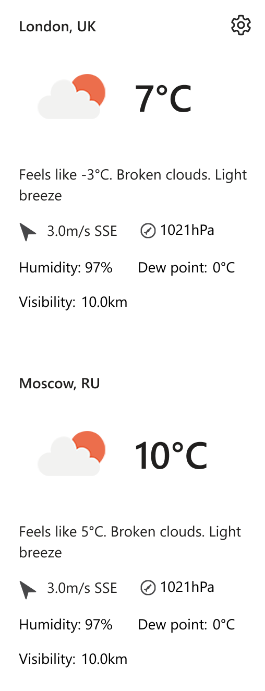  
     
   The presentation may differ, this is just an example.
3. Get data for the widget from [free public API](https://openweathermap.org/current). You must register an account at OpenWeather.
4. After clicking the ‘Gear’ button at the upper-right corner, switch the view to the following:  
     
   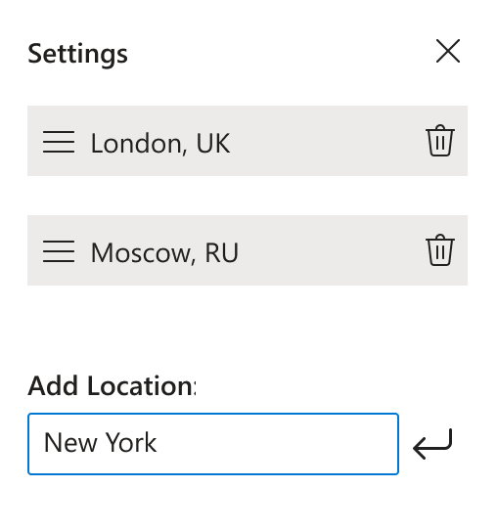  
     
   Here, a user must be able to:  
   1. Remove previously added cities.
   2. Reorder the cities by dragging and dropping them within the list using ‘Hamburger’ icon to the left from the city name.
   3. Add new locations.
5. Save the configuration in the local storage and restore it on future visits. A user should be able to configure the widget just once and then have the same view until they change the computer or clean the storage.
6. By default, on initial opening, request the current user’s location and display the weather in their city.

**Important:** UI of your app may differ. You can use any CSS frameworks and UI libraries. We evaluate the quality of your code and UI/UX. The app is quite basic but consider it as a real-life application that is going to be supported and intensively improved by a team.

**Deadline:** there are no strict deadlines. We understand that you may be working on another job. It would be great if you could complete it within a week.

Send your solution to [contact@plumsail.com](mailto:a.cherina@plumsail.com).